Reaction Paper 3 (Chapter 4)

Angie McCormick

EHRD 690- Introduction to Statistics

Dr. Khalil Dirani

Texas A&M University

June 24, 2021

Section1:

Chapter 4 explains the use of all standard scores, which inherently carry meaning for a large portion of the population because their mean and standard deviation are known. This chapter additionally explains the dynamic use of the *z* distribution for determining proportions and percentiles. The z distribution works to reinforce the empirical rule that dictates the percentages of scores to fall within one, two and three standard deviations of the mean. I noted the willingness of Coolidge to acknowledge the less praiseworthy aspects of the founders and formers within modern statistics. He does this as he confronts the “racist and pernicious” thoughts held by Karl Pearson. While these details do not change the math, they remind me that the entire process is human. And I personally think we are a stronger society when we can honestly acknowledge the failures and short comings of ourselves and others while not erasing their contributions.

Section 2:

The use of the z distribution and specifically the ease to access percentages could be used in the HRD work setting to quickly ascertain if a team were performing significantly above or below the average. This tool could help alert you to internal problems or difficulties before they developed into external problems. Having a common “language” of scores would allow teams across the organization to compare and self-assess progress and or lack thereof.

Section 3:

p. 130 question 5. Using the z distribution table, find the proportion of the total area for the following, draw a picture of each, and shade the target area.

1. Between a z score of 0.00 and a z score of 1.64
   1. 44.95%



1. Above a z score of 1.64
   1. 5.05%



1. Between a z score 0.00 and a z score of -1.00
   1. 34.13%

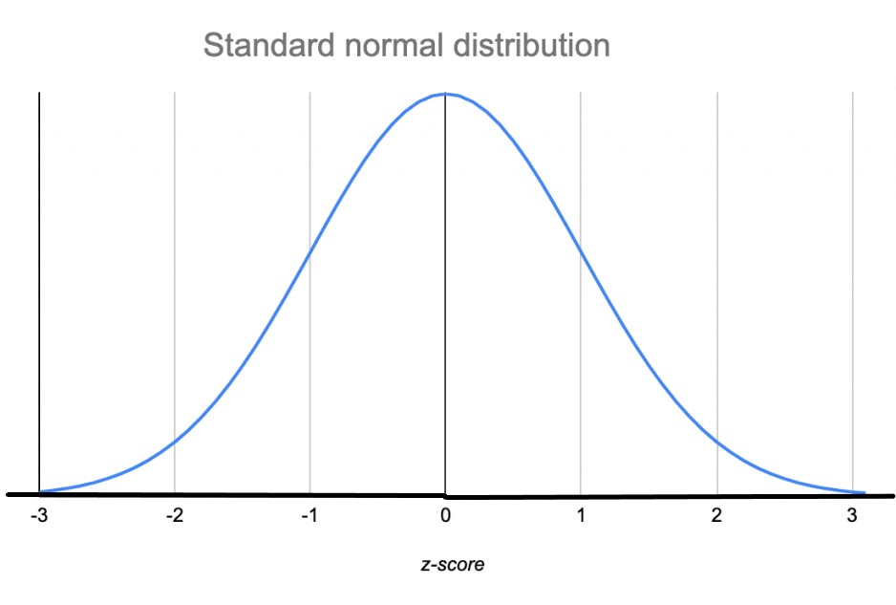



1. Below a z score of -1.64
   1. 5.05%



1. Below a z score of 0.00
   1. 50.00%



1. Between a z score of -1.00 and a z score of 1.00
   1. 68.26%



1. Between a z score of -2.00 and of -1.00
   1. 13.59%

