Research Proposal

Angela McCormick
Educational Administration & Human Resource Development, Texas A&M University
EHRD 627: Research & Development in EHRD
Dr. Glenda Musoba
August 3, 2020

Introduction
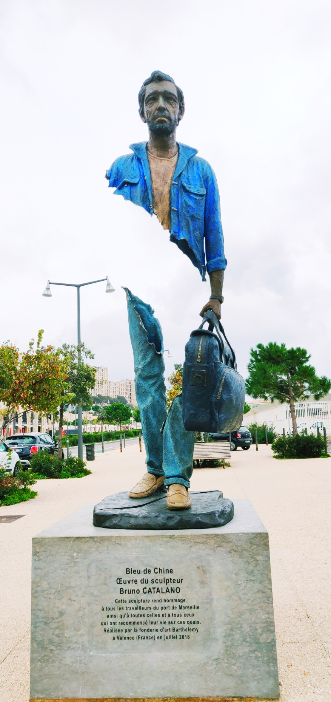
Marseille, France is one of the oldest ports in the world. It dates to 600 BC and since these early days it has been a multicultural melting pot of peoples for the Mediterranean region and the globe. At times it has exhibited the best of intercultural respect and communication and at times it has revealed the very worst. Adding to this tension is the social and state insistence that there is no African French or Arab French, there is only French. In an effort to equalize backgrounds there is an unnecessary erasing of them. The racial justice dialogue that is pulsing in the United States with great momentum for change is churning under the surface in France and its ever-present beating can be felt and seen in the port city of Marseille. This city needs understanding of the marginalized communities that comprise its neighborhoods. Who do they call themselves? Where did they come from? How did they come here? What do they value and how do they feel? Building a stronger community comes through an increase in justice, honor, and opportunity for understanding and dialogue. One of the best ways to build connections between people from differing backgrounds is through listening to others’ stories and discovering our own assumptions. Marseilles is working to empower its sizeable immigrant population through increased social programs that specifically target the marginalized or at-risk communities. But seeking ways to honor the immigrants’ journey and identity is often sacrificed in the process. Often direct conversations regarding race, religion or ethnicity can illicit defensiveness or judgment. Immigration can be a political issue that rouses people’s anger and fear. Art however, is one way is to sidestep the typical cultural triggers and create a shared learning space. Art can be a disarming approach to discover the perceptions, stories, pain and pride that each of us carry. Bruno Catalano is French sculpture. Born in Morocco to a Sicilian family he imbodies the multicultural nature of Marseille. Bleu de Chine (Catalano) provokingly stands on the sidewalk at the port in honor of laborers and all those who began their new lives on the quays . It is one of his many sculptures. This sculpture is a doorway into a world of dialogue and discovery. Could art serve to create the space to encourage dialogue, empathy and increase understanding? What if we were able to ask residents of Marseille to “look at this sculpture and find out what they think and feel? And what if we were able to ask them that in a way that minimized social barriers between the interviewer and the interviewee? What might come as a community reflected a bit more deeply on the people that make it up? And what if people signed up to hear what their neighbors thought too? What if? That is exactly what I endeavor to do in this study.

Literature Review
Adolphe Thiers was a French statesman and historian. His words from the nineteenth century continue to bear relevance on the issues of immigrated peoples today. “A man has all his moral value, according to us, only in the middle of his fellow citizens, in the city where he has always lived under the eyes of those citizens, watched, judged, and appreciated by them ... but in general the displaced person, whom we call a vagabond, no longer has his moral value.” (Thiers, 1991) This study seeks to play a small part in the reconstruction of a communal moral value. However, attempts to study race and immigration in any context quickly uncover the minefield of obstacles laying just below the surface. It is for this reason that in since the early 2010s, there has been an increase in creative approaches to racial justice dialogue. Additionally, methods of Large Group Dialogue (LGD) have proved profitable to increase awareness, empathy and bring about opportunity for change. This study is not a formal LGD, but it is facilitating the collecting of multiple voices for the same purposes. The TREC (Talking Race, Engaging Creativelysm) model, is described as one example combining both practices. (Lark, 2005) The TREC model utilizes art to shift power in the dialogue allowing those with quieter voices to be heard. Likewise, in this study we seek to employ the power shifting capabilities of art to equalize voices and disarm defenses. These methods have been carefully examined through the millennia long history of Marseille as a melting pot of cultures. And they have been scrutinized with the help of anthropological writers like Mary Dewhurst Lewis as she illuminates the current immigration climate considering the last two hundred years of people and policy. (Lewis, 2002)

Methods
Sampling a population of an amorphous metropolitan area of a million people is a dynamic task whose outcome will determine the significance or relevance of the study. When you consider that the metanarrative of the city is the amalgamation of stories of all the people who live there, any sample size seems small. Typically, the reasons for smaller sample size are the resources and constraints of the study or the researchers themselves. (Fraenkel, Wallen, & Hyun, 2016). But if we are interested in hearing the responses and stories of a city, we must look for the broadest sample possible to achieve saturation. We expect to reach XXXX people without survey invitation and based off of similar web-based survey we expect an engagement rate of In order to manage a large sample size, we will work in partnership with La Maison Bernadette, a local association that partners with marginalized communities to strengthen families. As you consider all the things that a diverse metropolitan area does not share it is critical to realize that there are certain spaces that they do all hold in common. By accessing those portals, we can access a significant percentage of the population. What are these shared spaces regardless of income, stage of life, and language: metros, markets and Facebook.
This study will make use of convergent mixed methods approach to survey research (Creswell & Creswell, 2018). The goal is to provide a significant foundational data while also making room for the human stories to shape the research findings and influence further studies. There are elements of experimental research in the final question as well as a subtle advocacy lens in the study. At the heart of this study is the question does art create the space to encourage dialogue, empathy and increase understanding of immigration issues? Could we capture and analyze that in a study? Yes and yes.

Procedure
The Bleu de Chine sculptures were installed in the area with great foot traffic (near metro stops and markets) in each neighborhood in the city of Marseille for the month of April 2021. The month of April was chosen because of the favorable weather which further increases foot traffic. Potential participants were solicited through a localized Facebook Advertising Campaign. The process was intentionally designed to access the largest sample possible and maintain a comfortable environment where the participant could respond from the comfort of his/her own device and minimizing the impact of the role of the interviewer.

Instruments
Facebook pop-up advertisement – For the month of April 2021 a Facebook pop-up advertisement campaign will be launched with an image of the Bleu de Chine sculpture with a question: Have you seen me? written in French, Arabic, English, Spanish, Armenian, Tamazight, etc. “Users 65 years and older are the fastest-growing group on Facebook,” (Aboulhosn, 2020) which means Facebook is becoming increasingly representative of society. When the ad is clicked on it will open our research website which informs the participant of the length of the survey as well as the prizes they can enter to win. These incentives are sponsored by the city of Marseille and include art lessons for adults or children, boat tours of nearby attractions, public transportation passes, etc. Our website will allow us to guarantee the participant’s anonymity unless they chose to identify themselves.
Language question: The first question is which language to use with the participant. This is a question designed both for data purposes and for ease of use purposes for the participant.
Open-ended questions: Then next series of questions asked are (1) What do you think the sculpture is about? (2) How does it make you feel? (3) Do you know anyone who has immigrated here? (4) Tell me about that experience. (5) What would help people who are arriving or living like this man?” Each of these questions is answerable in the language preference of the participants choice and can be as long or as short as the participant chooses.
Demographic questionnaire: After these open-ended questions a demographic questionnaire including birth year, languages spoken at home, race (you can select as many as you’d like) and gender will be asked.
Experimental/advocacy final question: The final question is if the participant would you like to know how other residents answered these questions? And will be given the opportunity to give contact information. This step will also give the option to choose which prizes the participant would like to register for the chance to win. This step is not required.
The four main threats to the internal validity in survey studies are mortality, location, instrumentation, and instrument decay. (Fraenkel, Wallen, & Hyun, 2016) These threats have been significantly reduced or eliminated due to the nature of the survey being an online portal in the safety of their own context without the external influences or human limitations.

Analysis
At the end of April the site will no longer accept survey results and the Facebook advertisement will be taken down. Facebook will provide us with the statistics of how many people saw our ad and how many people clicked on it. We will then compare that number with our total number of surveys. Our survey data will be divided into quantitative and qualitative data and analyzed for manifest and latent content (Fraenkel, Wallen, & Hyun, 2016). The quantitative questions will be computer analyzed and categorized due to the simplicity of yes/no, or multiple-choice questions. The qualitative portion will be read and coded by a trained team from La Maison Bernadette. This team will perform initial manifest coding tasks related to questions 1-5 from the open-ended questionnaire:
- Coding for question 1: will indicate the initial interpretation and response to the sculpture by use of a binary (1) or (0). (1) reflecting the reference to immigrant, traveler, etc. (0) reflecting some other interpretation.
- Coding for question 2: will indicate the use of which emotional descriptors (P) for positive emotional descriptors (i.e. happy, good, optimistic, safe, love, trust, joy), (N) for negative descriptors (i.e. sad, angry, hurt, disgust, shame, despair, loss, contempt, disapproval,), (U) for uncomfortable descriptors (i.e. shock, surprise, confused, awkward, anxious, pensive) are used as well as the (0) absence of an emotional descriptors.
- Coding for question 3: To indicate when participants have: a personal story of immigration (PS), a secondary story (SS), meaning that know someone who has immigrated, or none (N), meaning no connection to an immigrant story.
- Coding for question 4: To indicate if that story had: an overall tone of positivity (+) circumstances worked out, negativity (-) circumstances went very poorly, or neutrality (/) indistinguishable tone.
- Coding for question 5: To indicate if where assistance should come from: personal initiative (PI), social assistance (SA), or the state (S).
A second analysis of the survey will be coded for more latent content as the researcher reads over the survey and assesses the degree of empathy present through the written in responses overall. This technique in isolation presents costs to the reliability of the analysis, but in tandem with the manifest analysis works to provide a more robust picture.
This coding will be incorporated to the larger data collection of language selection, demographics, and desire to hear other’s responses to yield a greater understanding of how the people of Marseille see each other and themselves through the lens of art. It is our aim to compile foundational data for further studies in this topic through the execution of this study. Thanks for reading.

References

Aboulhosn, S. (2020, May 4). 18 Facebook statistics every marketer should know in 2020. Retrieved from SproutSocial.com: https://sproutsocial.com/insights/facebook-stats-for-marketers/
Catalano, B. (n.d.). Bleu de Chine. Marseille, France.
Creswell, J. W., & Creswell, J. D. (2018). Research Design: Qualitative, Quantitative & Mixed Methods Approaches, 5th edition. Los Angeles: Sage Publications Inc.
Fraenkel, J. R., Wallen, N. E., & Hyun, H. H. (2016). How to Desgin and Evaluate Research in Eduation, 9th edition. New York City: McGraw-Hill Education.
Lark, C. V. (2005). Using Art as Language in Large Group Dialogues: The TRECsm Model. Journal of the American Art Therapy Association, 24-31.
Lewis, M. D. (2002). The Strangeness of Foreigners, Policing Migration and Ntion in Interwar Marseille. French Politics, Culture & Society, 65-96.
Nasiali, M. (2016, June). Native to the Republic; Empire, Social Citizenship, and Everday Life in Marseille since 1945. Ithaca : Cornell University Press. Retrieved from https://doi.org/10.1093/ahr/123.3.1031
Thiers, A. (1991). "Discours parlementaire" (1850), cited by John Merriman, The Margins of City Life: Explorations of the French Urban Frontier, 1815-1871. New York and Oxford: Oxford University Press.

